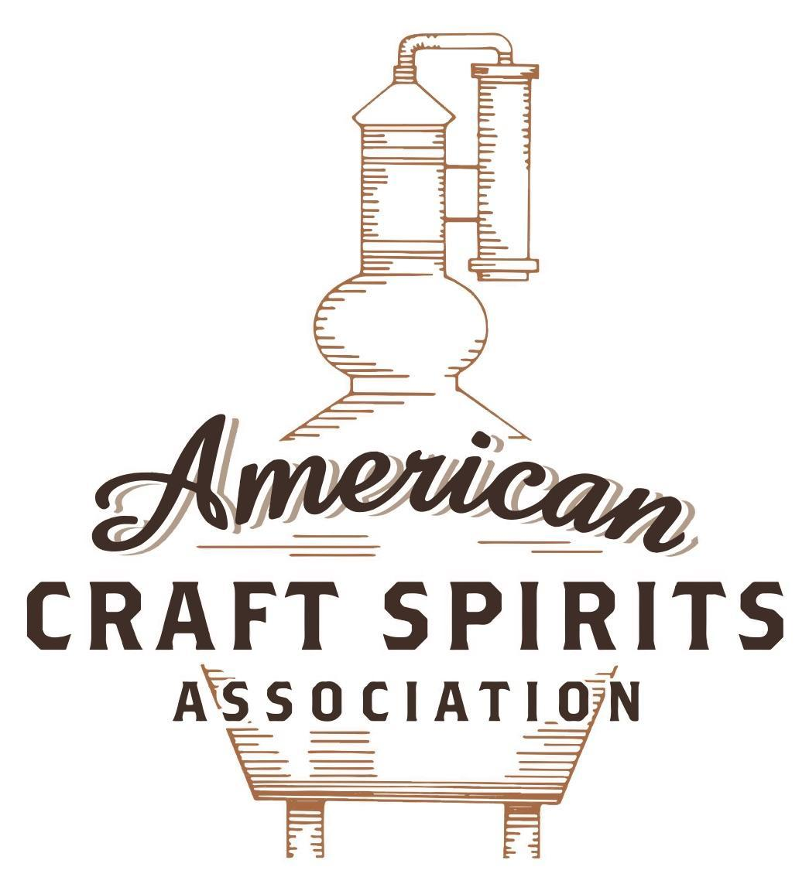
Spirits DtC Shipping Guide

This guide summarizes the direct-to-consumer shipping rules for distilleries in all 50 states and D.C. and also addresses the measures state governments have taken to ease delivery and shipping restrictions during the COVID-19 pandemic.

DtC Quick Guide Comparison

Out-of-State Distilleries  Can Ship Into State? |  |  |  | In-State Distilleries  Can Ship Within State?
State | Yes | No |  | State | Yes | No
AL |  | X |  | AL |  | X
AK | X |  |  | AK | X
AZ | X |  |  | AZ | X
AR |  | X |  | AR |  | X
CA |  | X* |  | CA |  | X*
CO |  | X |  | CO |  | X
CT |  | X* |  | CT |  | X
DE |  | X |  | DE |  | X
DC | X |  |  | DC | X
FL |  | X |  | FL |  | X
GA |  | X |  | GA |  | X
HI |  | X* |  | HI |  | ?*
ID |  | X |  | ID |  | X
IL |  | X* |  | IL |  | X*
IN |  | X |  | IN |  | X
IA |  | X* |  | IA |  | X*
KS |  | X |  | KS |  | X
KY | X |  |  | KY | X
LA |  | X |  | LA |  | X
ME |  | X* |  | ME |  | X*
MD |  | X |  | MD |  | X
MA |  | X |  | MA |  | X
MI |  | X |  | MI |  | X
MN |  | X |  | MN |  | X
MS |  | X |  | MS |  | X
MO |  | X |  | MO |  | X
MT |  | X |  | MT |  | X
NE | X |  |  | NE | X
NV |  | X* |  | NV |  | X
NH | X |  |  | NH |  | X*
NJ |  | X* |  | NJ |  | X*
NM |  | X |  | NM |  | X
NY |  | X* |  | NY |  | X*
NC |  | X |  | NC |  | X
ND | X |  |  | ND | X
OH |  | X |  | OH |  | X
OK |  | X |  | OK |  | X
OR |  | X |  | OR | X
PA |  | X* |  | PA |  | X
RI |  | X* |  | RI |  | X
SC |  | X |  | SC |  | X
SD |  | X |  | SD |  | X
TN |  | X |  | TN |  | X
TX |  | X |  | TX |  | X
UT |  | X |  | UT |  | X
VT |  | X |  | VT |  | X
VA |  | X |  | VA |  | X
WA |  | X* |  | WA | X
WV |  | X* |  | WV |  | X*

WI |  | X |  | WI |  | X
WY |  | X |  | WY |  | X

Notes:
*CA: If passed and signed into law, Senate Bill 620 would allow licensed distilled spirits producers in states other than California and licensed distilled spirits manufacturers or craft distillers in California who obtain distilled spirits direct shipper permits to ship directly to consumers in California
*CT: Consumers with appropriate permit may receive alcohol shipments
*HI: Consumers with appropriate permit may receive alcohol shipments; If passed and signed into law, Senate Bill 65 would allow licensed distilled spirits manufacturers in Hawaii and in states other than Hawaii who obtain direct shipper permits to ship directly to consumers in Hawaii
*IL: If passed and signed into law, Senate Bill 0532 would allow licensed distilled spirits producers in Illinois and in states other than Illinois who obtain distillery shippers’ licenses to ship directly to consumers in Illinois
*IA: If passed and signed into law, House File 639 would allow native distilled spirits manufacturers in Iowa and in states other than Iowa who obtain direct shipper permits to ship directly to consumers in Iowa and to consumers in states other than Iowa
*ME: If passed and signed into law, Legislative Document 1358 would allow distilleries outside of Maine with current manufacturer licenses and distilleries licensed in Maine who obtain spirits direct shipper licenses to ship directly to consumers in Maine
*NJ: (1) If passed and signed into law, Assembly Bill 3167 would allow a craft distillery licensees to ship no more than 9 liters of distilled spirits to a consumer in New Jersey; (2) If passed and signed into law, Senate Bill 3020 would allow craft distillery licensees in New Jersey or in states other than New Jersey to ship no more than 20 liters of distilled spirits to a consumer in New Jersey via common carrier
*NV: Licensed individuals can import one gallon per month of spirits for personal use and the out-of-state supplier must pay excise tax
*NH: If passed and signed into law, Senate Bill 125 would allow licensed liquor manufacturers who obtain direct to consumer shipping permits from the commission to ship directly to consumers in New Hampshire
*NY: Consumer may import up to 90L of liquor per year for personal use without a license; If passed and signed into law, Assembly Bill 3275 would allow licensed liquor manufacturers in states other than New York and licensed distillers and farm distillers in New York to ship no more than thirty-six cases (no more than nine liters per case) of liquor to consumers in New York
*PA: Consumer may place a special liquor order and distiller must ship to a PLCB-operated store
*RI: Distiller can only ship to customer if order was personally placed by customer at distiller's premises
*WA: If passed and signed into law, House Bill 1432 would allow licensed spirits manufacturers in states other than Washington to ship spirits to consumers in Washington
*WV: Distilleries, mini-distilleries, or micro-distilleries licensed in West Virginia or a state other than West Virginia who obtain private direct shipper licenses to ship to a consumer in West Virginia, however the shipments must be made to a retail liquor outlet

OREGON
Shipment Outbound – Yes (ORS 471.230(1)).
Shipment Inbound – No (ORS 471.404).
Shipment Intra-state – Yes, Distillery Retail Agents may deliver distilled spirits manufactured at their distilleries to consumers directly or through an approved for-hire carrier (OLCC 845-015-0141; 845-005-0424).
COVID-19 Measures – The temporary authorizations allowing distillery retail agents or approved for-hire carriers to deliver distilled spirits manufactured at distilleries to consumers directly have been made permanent (see above).
Citation (shipment)
Oregon Revised Statutes
471.230 Distillery license.
(1) A distillery license allows the licensee to import, manufacture, distill, rectify, blend, denature and store distilled liquor, to sell the distilled liquor to the Oregon Liquor Control Commission and to transport the distilled liquor out of this state for sale outside this state. Distillery licensees may purchase and sell distilled liquor from or to another distillery licensee in containers having a capacity greater than one U.S. gallon for blending and manufacturing purposes. A distillery licensee may not sell any alcoholic beverage within this state except to the commission or as provided in this section. However, any agricultural producer or association of agricultural producers or the legal agents of an agricultural producer or association of agricultural producers that manufactures and converts agricultural surpluses, by-products and wastes into denatured ethyl and industrial alcohol for use in the arts and industry are not required to obtain a license from the commission.
(2) If a distillery licensee holds a valid distilled spirits plant basic permit issued by the federal Alcohol and Tobacco Tax and Trade Bureau for the licensed premises, the distillery licensee may:
(c) Apply for appointment by the commission as a distillery retail outlet agent for purposes of retailing distilled liquor at locations where tastings are permitted under paragraph (a) of this subsection or subsection (4)(a) of this section. A distillery retail outlet agent may sell at locations where tastings are allowed under paragraph (a) of this subsection only distilled liquor that is on the list of products approved by the commission for retail sale in Oregon and is manufactured in Oregon by the distillery licensee or by another distillery licensee that uses the same premises as a primary production location or is owned by the same entity as the distillery licensee.
(4) A distillery licensee that holds a special events distillery license may conduct an event on premises designated in the special events distillery license. Except as provided in this subsection, a special events distillery license may be valid for a period not exceeding five days. The commission shall limit the approval of special events distillery licenses for a distillery licensee at the same location to not more than 62 days during a calendar year. A distillery licensee conducting a special event may:
(c) If the distillery licensee has been appointed as a distillery retail outlet agent under subsection (2)(c) of this section, sell distilled liquor in factory-sealed containers for consumption off the licensed premises. A distillery retail outlet agent may sell at a location where tastings are allowed under paragraph (a) of this subsection only distilled liquor that is on the list of products approved by the commission for retail sale in Oregon and is manufactured in Oregon by the distillery licensee. The distillery retail outlet agent must sell the distilled liquor at the retail price set by the commission for the month of sale.

471.404 Importing liquor without license prohibited; exceptions; fee. (1) Alcoholic liquor may not be imported into this state by any person other than a holder of a brewery, winery, distillery or wholesaler’s license, except as follows:
(a) Alcoholic liquor ordered by and en route to the Oregon Liquor Control Commission, under a certificate of approval issued by the commission.
(b) Wines for sacramental purposes according to rules adopted by the commission.
(c) Alcoholic liquor that is in transit on a common carrier to a destination outside Oregon.
(d) Alcoholic liquor coming into Oregon on a common carrier according to orders placed by a licensed brewery, winery or wholesaler.
(e) Grain and ethyl alcohol for scientific, pharmaceutical, manufacturing, mechanical or industrial use, under a certificate of approval issued by the commission.
(f) Wine or cider that is sold and transported by the holder of a wine self-distribution permit to a retail licensee that has the endorsement described in ORS 471.274 (5).
(g) Malt beverages, wine or cider shipped directly to a resident of this state under a direct shipper permit issued pursuant to ORS 471.282.
(2) The commission may require importers of alcoholic liquor to pay a reasonable handling fee based on the quantity and type of alcoholic liquor being imported.
Link to Chapter 471: https://www.oregonlegislature.gov/bills_laws/ors/ors471.html
Oregon Liquor Control Commission
845-015-0141 Shipment of Distilled Spirits
(1) Retail sales agents must follow the Retail Operations Manual when shipping or delivering distilled spirits to a final consumer.
(2) Distillery retail outlet agents must follow the Distillery Retail Outlet Manual when shipping or delivering distilled spirits to a final consumer.
Link: https://secure.sos.state.or.us/oard/viewSingleRule.action?ruleVrsnRsn=272830
845-005-0424 Guidelines for Approval of a For-Hire Carrier’s Plan for Delivery of Malt Beverages, Wine, Cider or Distilled Spirits
The Commission will evaluate and may approve a for-hire carrier’s plan to deliver malt beverages, wine, cider or distilled spirits to a resident of Oregon.
(1) Delivery to a resident of Oregon. In order to deliver malt beverages, wine, cider or distilled spirits to a resident of Oregon, a for-hire carrier must make application to the Commission upon forms to be furnished by the Commission and receive approval from the Commission before delivering any malt beverages, wine, cider or distilled spirits to a resident of Oregon. The application shall include the for-hire carrier’s plan for ensuring that:
(a) Only persons age 18 or over will be used to deliver the alcohol to the resident;
(b) The person used to deliver the alcohol will verify by inspecting government-issued photo identification that the person receiving the alcohol is at least 21 years of age;
(c) The person used to deliver the alcohol will determine that the person receiving the alcohol is not visibly intoxicated;
(d) Deliveries of alcohol will be completed in accordance with the hours and allowable delivery locations in OAR 845-006- 0392 and OAR 845-006-0396;
(e) Any package containing alcohol is conspicuously labeled with the words “Contains alcohol: signature of person age 21 years or older required for delivery” or similar language approved by the Commission; and
(f) Information is collected that must be retained by the for-hire carrier for a minimum of eighteen months from the date of delivering the alcohol. The information may be collected and retained electronically (if the carrier so chooses) and must include:
(A) The date and time the alcohol was delivered to the resident;
(B) The name or information which can be used to determine the name of the person delivering the alcohol to the resident; and
(C) The name, signature, and delivery address of the person receiving the alcohol.
(D) The tradename and licensed or permitted address of the licensee or permittee that sold the alcohol for delivery to the resident.
(2) A for-hire carrier:
(a) Must allow the Commission to audit the carrier’s records which are directly related to alcohol deliveries in Oregon upon request and shall make those records available to the Commission in Oregon. The for-hire carrier must make these records available to the Commission no later than 60 days after the Commission sends the notice to the carrier; and
(b) Consents to the jurisdiction of the Commission and the courts of this state for the purpose of enforcing the provisions of this rule and any related laws or rules.
(3) The Commission may suspend, revoke, or refuse its approval of a for-hire carrier’s plan if the for-hire carrier fails to follow the plan approved by the Commission or comply with the provisions of this rule. A suspension, revocation, or refusal under this subsection is not subject to the requirements for contested case proceedings under ORS Chapter 183.
Link: https://secure.sos.state.or.us/oard/viewSingleRule.action?ruleVrsnRsn=272826

The American Craft Spirits Association (ACSA) is working diligently to give our members and industry partners relevant, current updates on statutes and regulations impacting production, sale and distribution of spirits. With the declaration of the novel coronavirus (COVID-19) in early 2020, many states have issued temporary policy changes or longer-term modernization of alcohol beverage laws. State statutes, regulations created by the state alcohol regulatory authority, as well as any other relevant guidance provided by such authorities (such as advisories, opinions, bulletins, etc.) were reviewed in creation of this document. No city or county ordinances were reviewed. Distillers should be aware that even in states where direct shipping is permissible, always remember to avoid shipping to dry counties. Please consult with your state guild or alcohol beverage authority for the most up-to-date information. This content is intended for educational and informational purposes only. ACSA's pro bono law firm of Malkin Law P.A. provided the core content found in this comprehensive overview of the spirits distribution after COVID-19. It was completed in August 2021 and will be updated regularly. If you have updates you would like to provide, please send to legislation@americancraftspirits.org or directly to the law firm at: ryan@malkin.law / malkin.law. Thank you.

